Chapter 3

RAMP-TRIM Users Manual

File Folder Module

United Nations Children’s Fund
3 United Nations Plaza
New York, New York 10017

Chapter 3. Folders

Table of Contents

3.1 Introduction: File Folder Registration Process 4
3.1.1 What is a Folder? 4
3.1.2 Determining Features of a Folder 4
3.1.3 How to Start a Folder 4
3.1.4 Additional Information on Listing Folders 5
3.1.5 Review of the File Folder Registration Process 5
3.1.6 How to Add or Modify Folders in the RAMP-TRIM Application 8
3.2 Screens Used in Folder Module 8
3.2.1 Identifying or Listing Folders 8
3.2.2 Adding a Folder Record 11
3.2.3 Modifying an Existing Folder Record 12
3.2.4 Adding Several Folders at Once (Copy Function) 20
2.2.5 Printing Folder Records 22
4. File Folders Exercises 24
3.5.1 Folder Listing and RAMP-TRIM Keys 26
3.5.2 Work Flow: Basic Steps to List Folders 26
3.5.3 Sample File Folder Label and Inventory Number /Org Location Label 26
3.6 Folder Listing: Self-Test 27
3.6.1 Questions 27
3.6.2 Questions and Answers 29

List of Figures

Figure 1. Typical Folder Subject Labels 7
Figure 2. Search/Find 9
Figure 3. Sorting the Search Results 9
Figure 4. Folder Search Screen 9
Figure 5. Select the Record Type 10
Figure 6. Record List (above) and View (below) Panes 10
Figure 7. New Folder Record Entry Form 11
Figure 13. Record Folder Notes Edit Screen 15
Figure 14. Container Search Form 16
Figure 15. Contact Tabbed pages in Record Form 16
Figure 17. Series Record field in General Tab Page 17
Figure 18. Select the Series Record Type 17
Figure 19. Use the Series Search Form 18
Figure 20. Use the Filter Tabbed page to select series type 18
Figure 21. Search Results 19
Figure 22. Record the Series Entry 19
Figure 24. Record Folder Date Field Edit Screen 20
Figure 25. Search Results for the title word test 21
Figure 26. Copy a Folder Record
Figure 27. Copy Folder Fields 21
Figure 28. Tag and Task Folders 22
Figure 29. Selecting Report Options 23
Figure 30. Standard RAMP-TRIM Report for CF_Series with Folder 23

3.1 Introduction: File Folder Registration Process

3.1.1 What is a Folder?

Athough it may seem apparent what a folder is, this is not always the case. In fact, for UNICEF purposes, a folder is anything that needs to be filed. Most records are in the form of the usual manila folders, yet there are other forms as well. For example, it could be a binder, a single tape or diskette or a CD-ROM. Unusual things in an office such as flags or gifts may need to be recorded or filed. All are issued a folder inventory label and entered into the RAMP-TRIM application as if they were a folder.

3.1.2 Determining Features of a Folder

In general, a folder is an item that has to be separated from other similar things. This need for separation is best exemplified by the separators in a binder, the tabs in a report, or logical, convenient breaks within a series of records. The folder title should be checked to see if it really reflects the content of the folder. If the need arises, another folder might be created or the present folder title changed to be more broad and inclusive.

3.1.3 How to Start a Folder

To create a file folder, you must enter certain data. Each folder should have the following:
Title describing its contents (e.g. UNICEF House Floor Plans, Diagrams #1): it is suggested that the first 30 title characters bear the most important information about the folder title, since usually these will be displayed first on most “list view” screens in the RAMP-TRIM system.

Folder code A unique External Reference – Local folder code reflecting some kind of shorthand classification system (such as the Global Classification Guide [GCG] Scheme outlined in Executive Directive CF/EXD/90-002, 1 February 1990: e.g. "AD-235".

Inventory The unique system generated file folder number formerly entered by hand in the RAMP-WANG system is automatically generated in the RAMP-TRIM system. This was called the inventory number [e.g. A001], also called an optional folder code or consecutive number label]. In RAMP-TRIM it is called the Expanded Record File Folder Number, this can also be used with barcoding.

Creation Date The starting date of the records should also be noted.

These items are necessary so that eventually a correct appraisal of the retention life of the records can be made.

However, if you are not sure what title to place on a folder give any of the first words that you find in the folder. At a later date a more specific or accurate title can be entered, since it is easy to change a folder number, code, or title in the RAMP-TRIM system.

3.1.4 Additional Information on Listing Folders

Deleting folders If a work unit wants to delete a folder or consider it for disposal, a separate series for holding these folders should be created. The series could be called Folders for Deletion or Series for Disposal with some mention of the original series. After the folder or series title, the notation (RET) should be entered in the RAMP-TRIM application.

Moving Folders in Series
It may be determined at a later date that a particular group of folders would be better maintained under a different series or even a different work unit. However, the data does not have to be re-entered; just contact RAM (Record & Archives Management, ext. 7662) and they will make the necessary changes within the RAMP-TRIM system.

Item listing An additional dimension is also contained in the RAMP-TRIM application: the ability to list individual items within a folder. Arrange with RAMP-TRIM coordinator to receive additional training on item entry if you wish to become proficient at this type of procedure.

Advantages to Listing Records
The advantages of entering lists of folders in the RAMP-TRIM system should be apparent. As the number of folders increases in the work unit, it will be much easier and more efficient to locate the records needed, either by users within the work unit or even by other interested parties within UNICEF who have approved access to record type in the RAMP-TRIM system.

Review of the File Folder Registration Process

The registration process involves several main tasks. Each task has several key steps.

Identify File folders to be listed from Local Folder Code

Review the list of Series registered for work unit

Locate the group of folders belonging to a Record Series. Folders with the original, handwritten or typed titles should be examined to determine to what series they belong. (folder title example: "UNICEF House Floor Plans" may belong to a series of administration-related files.)

Register File Folder Titles Make note of file folder titles, work units and consecutive numbers.
Choose an Alpha – Numberic local “shorthand” Code for Folder. ADD External Reference Local File Codes TO ALL FOLDERS to aid quick retrieval. You may wish to base the local file code on the Global Classification Guide [Annex D) (For example the folder "UNICEF House Floor Plans" could be coded: "AD-235" -- following the Global Code scheme:

AD-000 = Administration

AD-200 = Accommodations

AD-230 = Floor Plans & Diagrams

AD 235 = Floor Plans for Specific locations

If you are unsure of the codes and it might delay your progress, chose some simple prefix and consecutive number to start. After the files are listed in RAMP-TRIM a pattern might be more obvious. At that time you can change the codes in RAMP-TRIM.

Note a beginning date for the records contained in the folder (simply write in pencil on outside of the folder. (For example: "17/Oct/1989").

If the work unit has several hundred folders, it is probably most efficient at this point to get a Dictaphone and read the folder titles, dates, and codes if they are available, onto a tape. This has been found to be more efficient than shuffling through stacks of folders while simultaneously trying to enter the data into RAMP-TRIM. Later, obtain a transcriber and listen to your own voice tape and then comfortably enter the information from all your folders into RAMP-TRIM.

Printing RAMP-TRIM File Folder Labels

Below is the procedure for printing out file folder labels in RAMP-TRIM.

- The print format for RAMP-TRIM folder labels are found under the Menu- File - Print Report - CF_Folder_inv_Subj and is designed for use with Avery Address Label 5162 only.
- Each tagged record prints out a pair of labels. One label contains the record number of the RAMP-TRIM folders including a bar code; the other contains the folder title and external reference.
- Each page contains 7 pairs of labels. Therefore labels for 7 folders are printed per page.
- See Appendix C for details on how to print out RAMP-TRIM File folder labels.
After some testing of the printer in your area you should be able to print the labels you require on a regular basis.

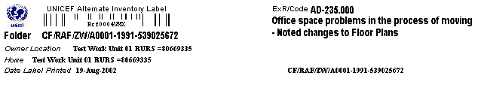Sample Inventory/Owner Location – System Generated Number Labels

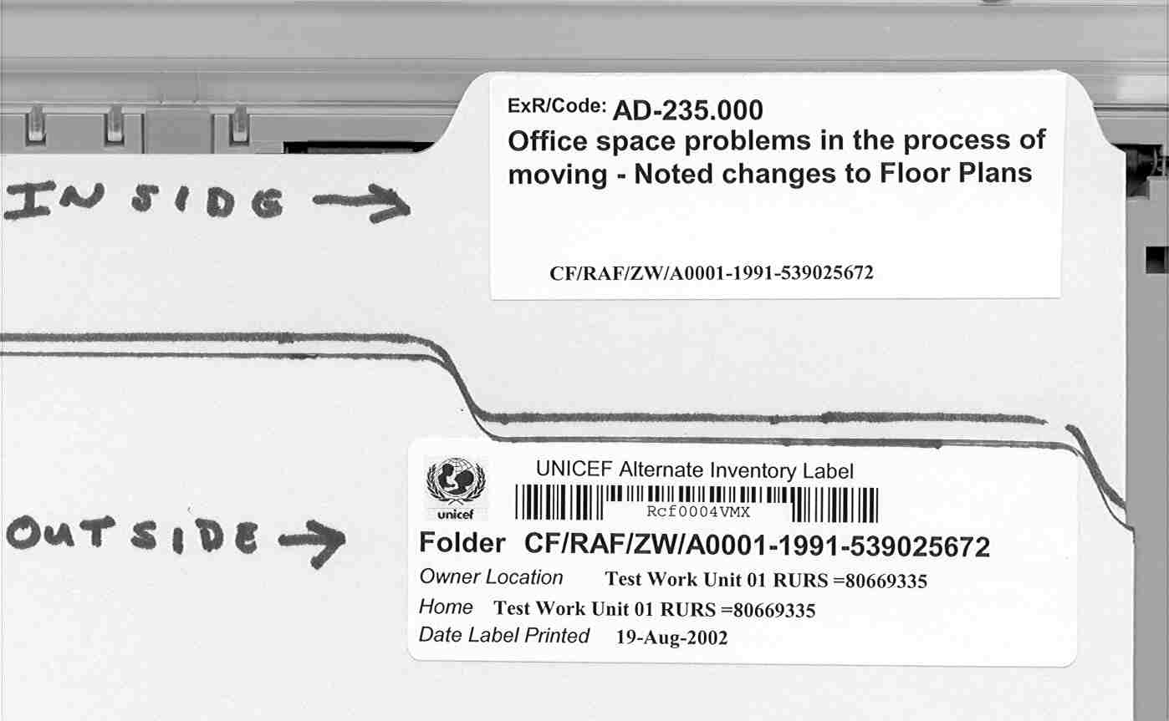
Figure 1. Typical Folder Subject Labels

Place RAMP-TRIM FOLDER LABELS on FILE FOLDERS.

- The Consecutive Number File Folder Label, containing the bar code, is placed on the outside of a folder, on the first side; not on the raised flap or tab on the back side.
- The Title Label should be placed on the tab, or if there is not a tab on the file, below the Consecutive Number File Folder Label.

- Prepare and Update the File Folder List. Identify who in the office updates the master list and where it is kept.
- Circulate the revised list of folders and codes used in each series.
- Encourage suggestions for additions/revisions from those who handle the files.

You now have an overview of the procedure for listing Folders in a UNICEF Office.

This work unit already used the Global Code as their own in-house code (which is not always done; they could have been using another coding system). Therefore in this case, their code is identical with the GCG Code translation which appears at the bottom of the label.

3.1.6 How to Add or Modify Folders in the RAMP-TRIM Application

There are five operations that are commonly performed when adding or modifying folders in the RAMP-TRIM application.

- Adding a Folder Record
- Modifying an existing Folder record
- Adding several Folders at once (Copy Record)
- Modifying an entire list of Folders (Tag/Task)
- Printing a list of Folders

The following procedures describe these RAMP-TRIM processes and have screen captures that illustrate the actions.

3.2 Screens Used in Folder Module

3.2.1 Identifying or Listing Folders
It is easy to list the Folders for a specific work unit in the RAMP-TRIM application. Use the following procedure to display folders sorted by the organisation:

At the TRIM Menu Bar navigate to Search, Find, and Search Method by Organization’s name (Hint the organization name field is found in the Locations field).

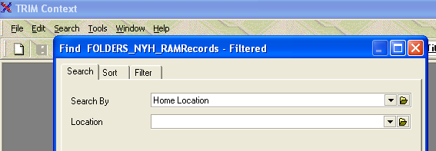

Figure 2. Search/Find

Use the Sort/Filter function key (see Figure 4) to designate the sequence in which folders will be presented. Select the Sort Field(s) Number 1. Typically you will select sort by Record Title, File Folder Expanded (Exp) Record Number, or ExtRef: Local File Folder Code in ascending order. Ascending order is the default value. The sort order can be changed to descending by checking the check box. Do not change the Disposition Filters or Class Filter values.

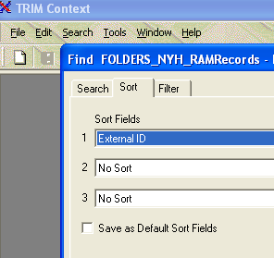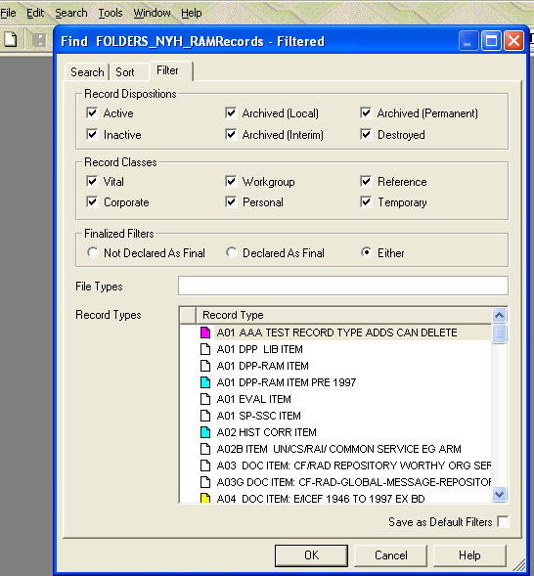

Figure 3. Sorting the Search Results

Enter the title word in search fields titled Title Word.

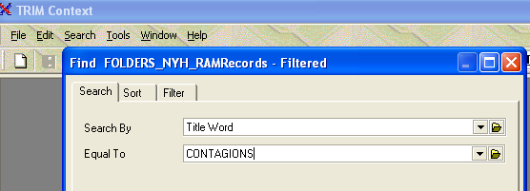

Figure 4. Folder Search Screen

Alternate Method: Enter at least 3 characters [e.g. Cont*] and use the Kwikselect or folder icon to open the word index, review the words indices and select a search term.

Select the Record Type button (Figure 5) in the Find search/filter panel and tag only the Folders type. Select OK to close the Select Record Type panel. Note that the Record Type selection can be set as a default value by checking the box titled Save as Default value.

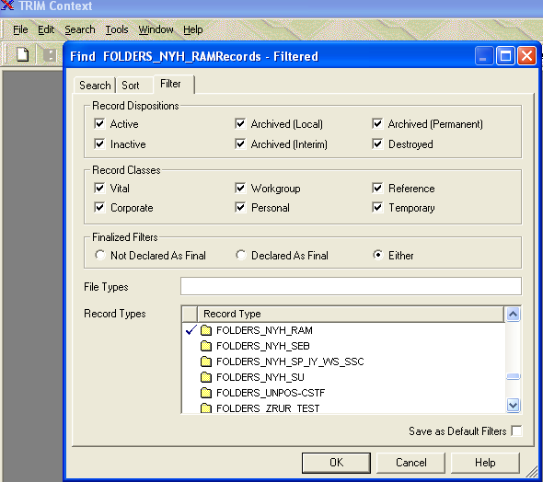

Figure 5. Select the Record Type

Select OK to execute the Search function .
Review additional information concerning a Folder by highlighting the folder record in the Record List Pane (search results panel displayed above) and reviewing the detailed information in the Record View Pane (search results panel displayed below).

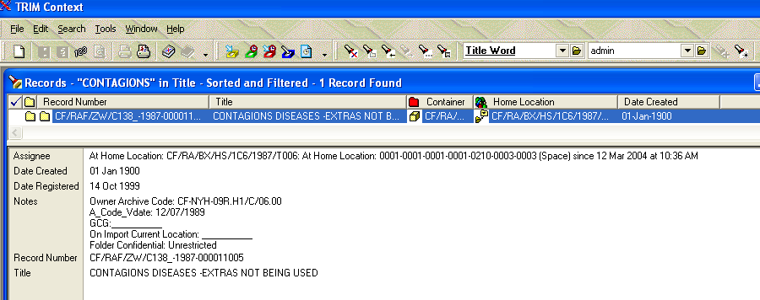

Figure 6. Record List (above) and View (below) Panes
Use the preceding steps to identify the record folders or review the record series definition for classification purposes.

Adding a Folder Record
Go to the Menu bar and navigate to the File, New Record (Ctrl-N), select The Folder record type and select Ok to display the New Folder entry form. You are now asked to enter information describing the folder record into select fields. Some fields are required [R], have default values [D], are optional [O] or have a combination of both. (see below).

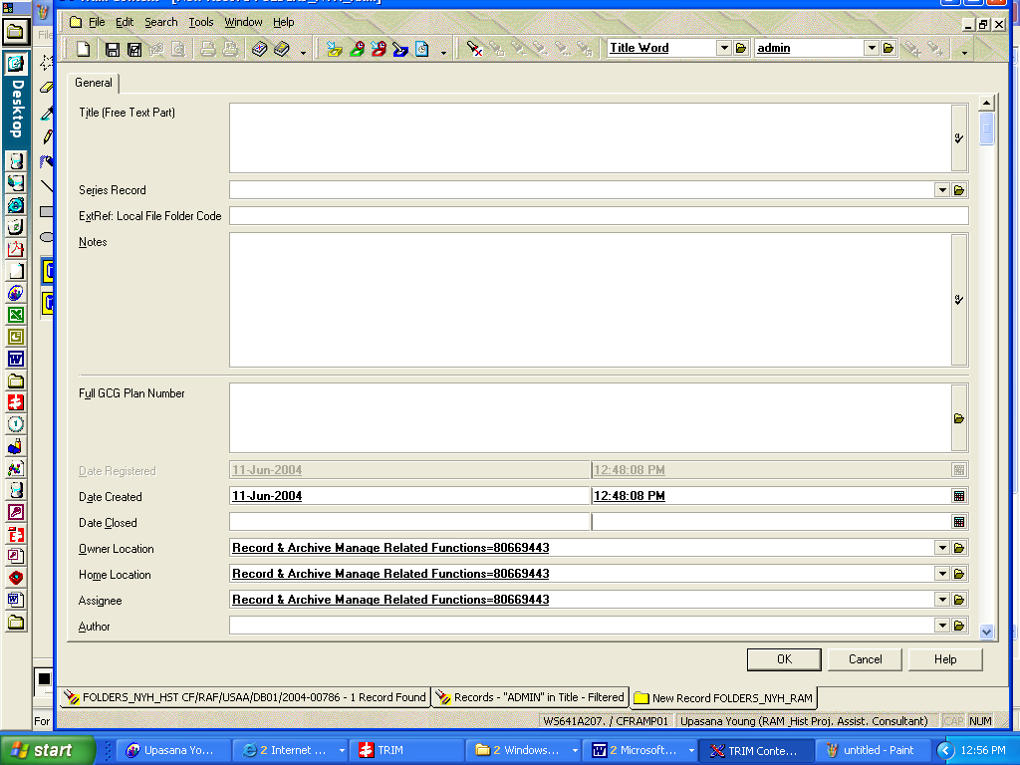

Figure 7. New Folder Record Entry Form

Record Title [R]: The title (alpha-numeric) applied to the folder helps in identification of folder. This is a required field and allows for 256 characters.

Series Container Record [R]: Select an appropriate series using the drop down yellow folder.

ExtRef: Local File Folder Code [O]: Enter information that will assist you in identifying the folder. Begin with the division, section and unit code followed by a short text or number. The title information should not be repeated in the ExtRef field. Remember to keep this entry short and do not repeat information already recorded in the Title field. Work unit prefix and year- number, (and any other information you want to include.) Strongly recommended.

Notes [O]: Descriptive text contributing to the researcher’s understanding of the folder records, or its use.

Full (GCG Code) Plan Number [O]: Use the Kwikselect feature to identify the value in the directory (locations) file.

Date Registered [R/D]: The date a folder was registered in RAMP-TRIM. The field is populated automatically.

Date Created [R/D]: The date folder was created. The field is populated automatically.

Date Closed [R/D]: The date the folder record was closed. The field is populated automatically. This field cannot be dated before the date created.

Owner Location [R/D] The organisation, unit or individual responsible for the series or series record. The field value will default to the division, unit or organisation. Use the Kwikselect feature to identify the value in the organisation directory (locations).

Home Location [R/D]: The organisation, unit or individual where the series records normally reside. The field value will default to the division, unit or organization. Use the Kwikselect feature to change the value in the directory (locations) file.

Assignee [R/D]: The field value will default to the division, unit or organisation. Use the Kwikselect feature to identify the value in the directory (locations) file.

Author [O]: Use the Kwikselect feature to identify the value in the directory (locations) file.

Other Contact [O]: If other individuals inside the organisation or outside the organisation are involved with this folder or the folder contents and it is important to record their contact information by entering the individual’s name(s) in here. Use the Kwikselect feature to identify the value in the directory (locations) file.

Save the completed Folder record using the menu under File, Save or use the diskette icon on the Menu Task Bar, or the fast path key combination Ctrl-S.

3.2.3 Modifying an Existing Folder Record
To modify or edit title go to File/Properties or right mouse click/Properties. The ‘General’ tab appears, along with tabbed pages with more data fields for easy viewing and editing via right mouse click on selected item/column. Go to title field and modify as appropriate.

Double clicking on an item, or list pange, will also open up the ‘Properties’ dialogue box to allow for adjustments and customization. As more data is added, more tab entries appear. When an electronic file is attached, double clicking however, will open the electronic file.

Right mouse click is context sensitive. Within dialogue boxes, right click on an item/pane/column to add or edit.

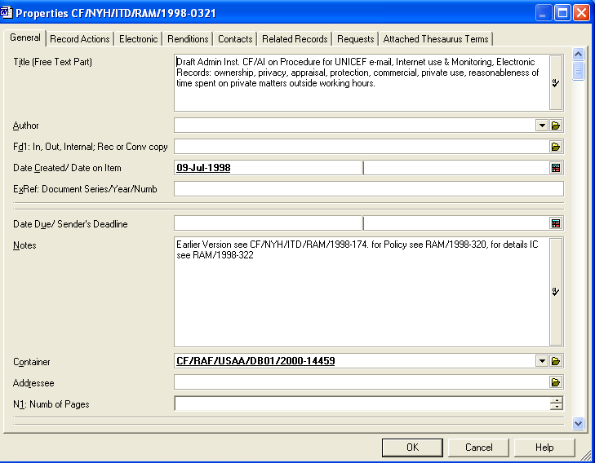

Figure 8. Record Entry Accessed after Form is saved with multiple tabbed pages for data entry, modifications

.

Tto modify the external ID, or to select/modify user fields or, right click and go to details/user fields

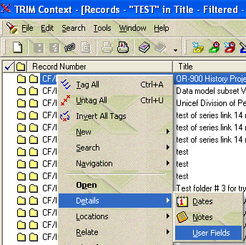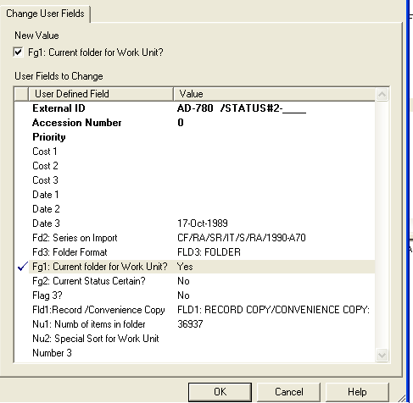

Figure 9. Record Entry Forms for User Fields, Numbers, Flags

Nu1 [O]: Number of items in the folder.

Nu2 [O]: Special sort field for work unit.

Fg1 [O]: Current folder for workunit.

Fg2 [O]: Status Certain

Field 1[O]: Record/Convenience copy

Field 3 [O]: Folder format, e.g. binder, cd-rom, etc.

As noted, not all the fields listed above are required. Consider the information that others will require in the future to locate your folders and enter the data appropriately.

3. The Folder record is automatically numbered, although you will be given a prompt to confirm record numbering. Select OK to create the record, or Cancel to return to the record entry form.

Note: It is possible for a user to create a record with a higher security level than they have access to, however they will not be able to view the record after its creation.

Active tasks are shown in bold type. Some Tasks may not be available to you due to security authorization. If you require access to select tasks which are not present on your screen contact the RAMP-TRIM Administration for authorization.

Modify – Notes Modify Open the notes modification window and edit notes as appropriate. Just prior to see the Record modification screen you will be asked, does this change apply to All Tagged Rows or the Currently Highlighted Row. Make the appropriate selection.

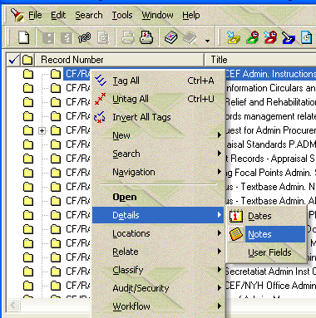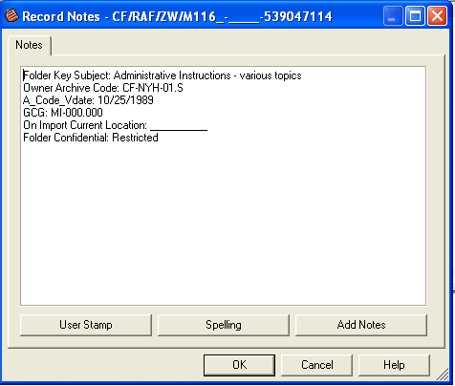

Figure 8. Record Folder Notes Edit Screen

Enter up to 30,000 text characters. This is a text field and has no word processing functions. Do not attempt to format this field because format settings are not saved. Apply spell check and the use stamp for audit purposes.

Modify - Containers Conduct a record search for a Folder record. Right click, go to Details/Location/Container. Check the box titled “Enclose the Record Now” if the folders are to be immediately placed in a box. Be sure the button titled “Set Container To” is checked. Use the drop-down list to review your most recently used containers, or use the Kwikselect to search for a container.

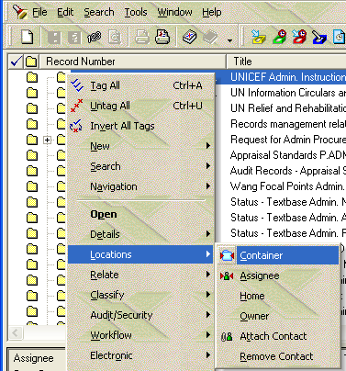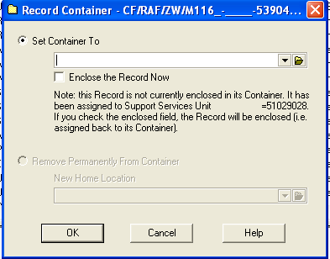

Figure 9. Container Search Form

Modify - Contacts Perform a record search for a Folder record. Right click, go to Properties, and select the Contacts tab from the tabbed entry pages. Right click for options. Select new contact and add from the Kwikselect drop down folder. Once saved, or to modify, right click on the contact name and select the contact type e.g. author, addressee, representative, or other. Only one type can be selected.
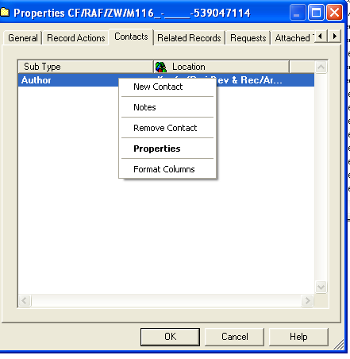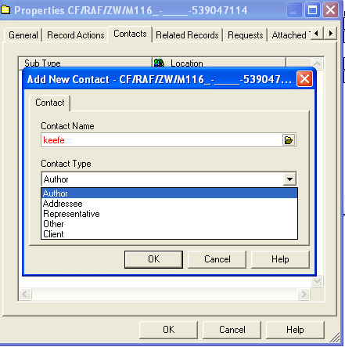

Figure 10. Contact Tabbed pages in Record Form

Modify - Series It may be necessary to reassign the record series or make an initial record series assignment. After completing a search, this function is accessed through Properties amd the General tab page, Series Record.

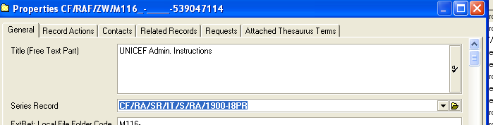

Figure 11. Series Record field in General Tab Page

Open the Kwikselect and details for the series record appears. Click on the search button on the lower right to locate a new series record.
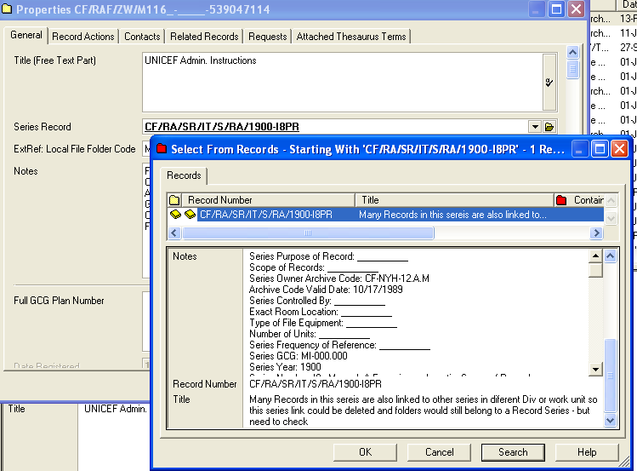

Figure 12. Select the Series Record Type

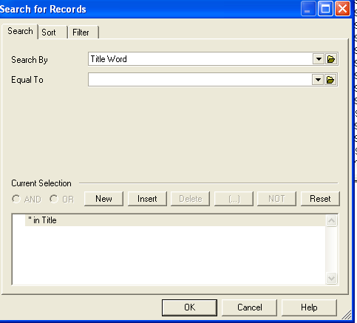

Figure 13. Use the Series Search Form

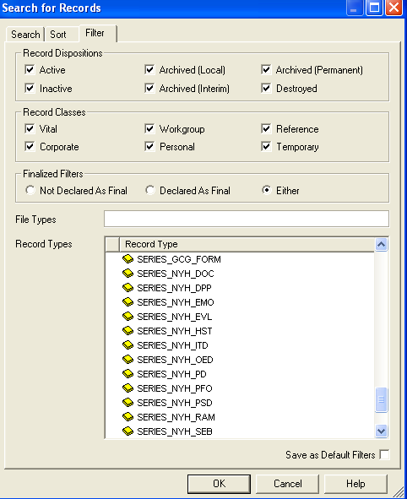
Figure 14. Use the Filter Tabbed page to select series type

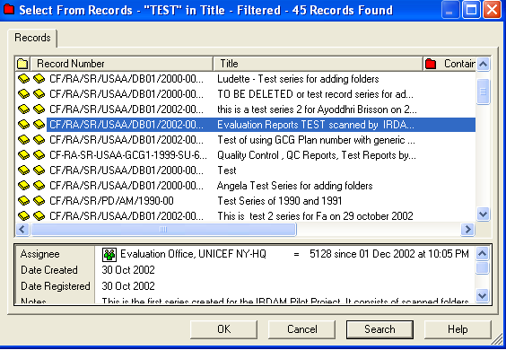

Figure 15. Search Results

Record Series search results are presented in a standard record list and record view panes. Select the OK button to send the selected records Series to the capture form.

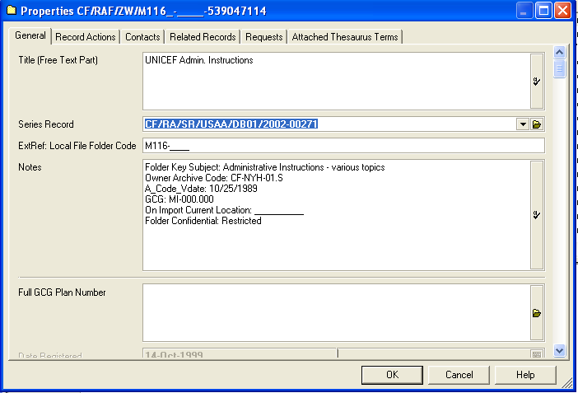

Figure 16. Record the Series Entry

Record the Record Series entry by selecting Ok, and the series is assigned.

Note that the Series Record has been assigned and displayed in the Record View Pane.

Modify – Dates Modify Open the date modification window and edit dates as appropriate. Just prior to seeing the Record modification screen you will be asked, does this change apply to All Tagged Rows or the Currently Highlighted Row. Make the appropriate selection.

Change a date via right click/Details/Dates. Check the active box and changing the date. Inactive date fields are underlit.
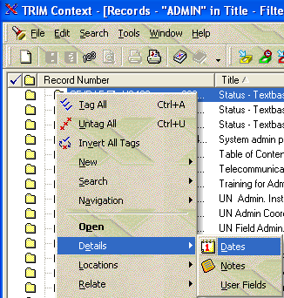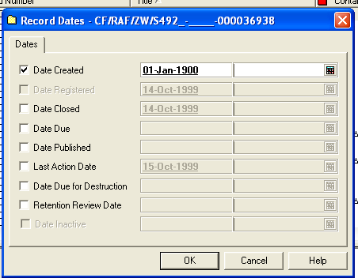

Figure 17. Record Folder Date Field Edit Screen

3.2.4 Adding Several Folders at Once (Copy Function)

If a work unit is entering their folder records into the RAMP-TRIM application for the first time or rearranging their records, it may be advisable to enter several similar folders at once. This process makes it unnecessary to repeat the same data over-and-over; this efficiency is achieved through the use of the copy record key. Using this procedure several new Folders are created in the RAMP-TRIM system at the same time.

Conduct a search as described in Section 3.2.1, Identifying or List Folders.

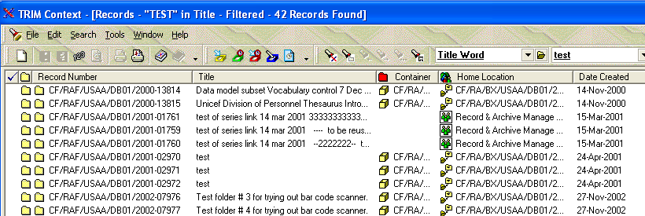

Figure 18. Search Results for the title word test

Tag or highlight the desired record. Navigate to the Menu Selection File, Copy Record.

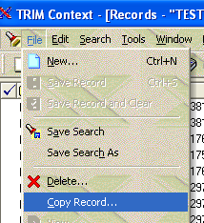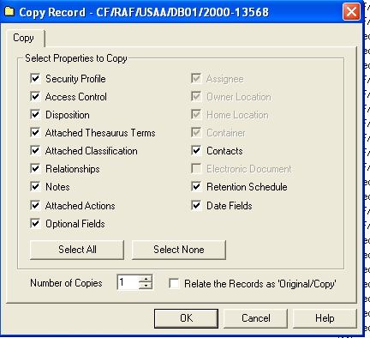

Figure 19. Copy a Folder Record Figure 20. Copy Folder Fields

In the Copy Record screen that appears, select the field qualities (fields or characteristics) to copy. Generally copy all fields unless it is necessary to change the field values.

Select the number of copies to generate. Exact copies of the records will be produced and it will be necessary to manually annotate each Folder record (usually the title field) copy to make them unique records.

Entire List of Folders (Tag and Task Functions 3.2.5 Modifying)

If a work unit is planning extensive reorganization, or is updating their records, it may be advisable to use a group change process of modifying basic Folder information, e.g. year, number, or title at the same time.

This procedure is called tag-and-task in RAMP-TRIM.
First find the desired records by conducting a search as described in Section 3.2.1, Identifying or Listing Folders.

Tag the records by locating the mouse just to the left of the yellow button or series icon. Depress the left mouse button to activate or deactivate the check mark – this is the selection indicator. Alternately, move the cursor to the right of the Yellow series icon and use the right mouse button to tag or untagged all records in the Record View Pane.

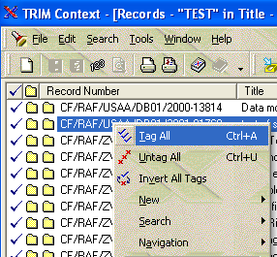

Figure 21. Tag and Task Folders

Any task now performed will apply to all tagged records. Refer to Basic Ramp-Trim Operations in Annex A for more information on Tasks.

2.2.5 Printing Folder Records

You may wish to print a Folder record or a list of Folder records. These reports, and many others, may be used by members of the organization. Use the following procedures to print reports.

Conduct a search as described in Section 3.2.1, Identifying or Listing Folders.

Select a folder by highlighting or select several records using the tag-and-task function.
Navigate to the Menu selection File (Alt.F), Print Report ( Ctrl-R), select the report titled CF Series. Enter the Optional Title and Select Preview and/or Print Report.

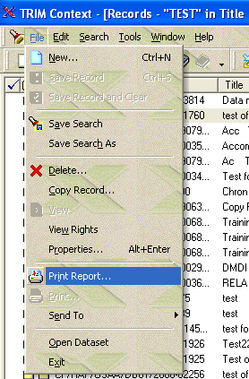
Figure 22. Selecting Report Options

The reports found in the RAMP-TRIM, File, Print Report are standard reports. Reports can also be customized for unique needs. Consult with the RAMP-TRIM Systems Administrator for information concerning customization of reports.

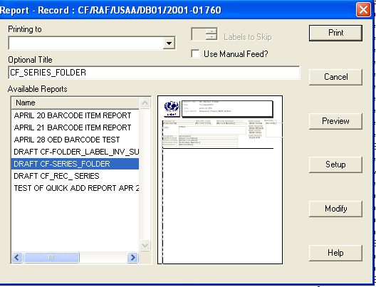

Figure 23. Standard RAMP-TRIM Report for CF_Series with Folder

4. File Folders Exercises

You have been assigned to TEST Work Unit___, in Test Section___, in Test Division___, in Ruratania Sub Office = RURS. Using RAMP-TRIM, find the work unit, list the Folder (24), and complete the following exercises:

1. List Folders in one Series [See Exercises at end of Chapter 2] for
"1985 003 Administrative Subjects (RET)"

2. Add the following Folders

Ext Ref
Local Code Title/Description Begin Date .
AD-000[ID] Admins Subjects General 01/01/1985

AD-200[ID] Accommodations - Housing 01/01/1985

AD-400[ID] Communications, Tel etc 01/01/1985

AD-800[ID] Travel related Cor & Doc 01/01/1985

3. Modify two Folders
CHANGE:
AD-000[ID] Admins Subjects General 01/01/1985

TO:
AD-000[ID] Admin. Subj. Gen. 01/01/1985

CHANGE:
AD-200 [ID] Accommodations - Housing 01/01/1985

TO:
AD-200[ID] Accomodat, House, Build 01/01/1985

- Set Default and Add four more Folders
AD-420[ID] Communication - MAIL 01/01/1985

AD-430[ID]…Communication - POUCH 01/01/1985

AD-460[ID]….Communication - TELEPHONE 01/01/1985

AD-470[ID]….Communication - TELEX 01/01/1985

5. List Modify
a) Change "Communication" to "Commun" on title, and
b) Insert the word "test[ID]" after Code in External Reference/Local Folder code in all folders.
e.g:

CHANGE: AD-420 Communication - MAIL 01/01/1985

TO: AD-420 Test Commun - MAIL 01/01/1985

CHANGE: AD-430 Communication - POUCH 01/01/1985

TO: AD-430 Test Commun - POUCH 01/01/1985
c) In Note field with user Id and date stamp in all test folders

3.5 Key Learning Points and Charts Used in Presentations

3.5.1 Folder Listing and RAMP-TRIM Keys

RAMP-TRIM File Folders Title Listing
Organization/Folder – Review
Chapter 1 Records for One work unit
Chapter 2 Series List
File Folder List – Introduction
Folders for One Series
Add (Local Folder Code, Title, Date)
Modify (Task: Modify, Extra detail)
Set Default (Copy Record)
Modify List (Tag/Task)

3.5.2 Work Flow: Basic Steps to List Folders

A | Identify Folders &  Series | What is the "Originating Office and Owner Location for the Records."
B | List File Folder information | As minimum, enter folder title, and local file code. Note Earliest date for contents
C | Place Inventory System Generated  Numbered Labels on File Folders | Place "Local File Folder Code" on folder if not already present.
D | Print File Folder List  (share with others who  use the files) | Can also Print new labels for folder titles. (useful for file reorganization or for beginning of year - opening new files)

3.5.3 Sample File Folder Label and Inventory Number /Org Location Label
Local folder Code/[ext ref] & Subject/Title Label - - - - ->
ExR/Code : [Local Folder Code]
Local Folder Title: Line 1
Folder Title: Line 2
Folder Title: Line 3
Folder Title: Line 4
CF/RAF/USAA/DB01/2000-NNNN [nnnn=consecutive number

Inventory Auto Registration Number Label - - - ->

Unicef Graphic | UNICEF Alternate Inventory Number
Unicef Graphic | Bar code and number  Rcg00cccc [cccc= unique system generated character]
Folder: CF/RAF/USAA/DB01/2000-NNNN [nnnn=consecutive number]
Owner Location: Division of Work unit
Home: [Work unit where folder kept or storage container]
Date label Printed: 10 Feb 2000

3.6 Folder Listing: Self-Test

3.6.1 Questions

Review of questions from Chapter 1, Overview and Organizational Work Unit.

1. Q. What three ways are possible to find your work unit?
2. Q. What is the difference between the "Work Unit" and the "Series of Records"?

Review questions from Chapter 2, Series of Records.
1. Q. What are the determining features of a series?
2. Q. Do you start a new series for each box of records or file folder?
Self Test for "Listing of Folders" module (Questions and Answers):

3 Q. What is a folder for the RAMP-TRIM system?
A. .

4 Q. What are the determining features of a folder?
A.

5 Q. What information must be on each folder?
A.

6 Q. If you are not sure what title to give a folder, what do you do?
A.

7 Q. Do you start a folder for each paper in folder or box?
A.

8 Q. Once you have entered approximately 100 folder titles, what do you do?
A.

9 Q. What do you do if you want to delete folder or consider it for disposal?
A.

10 Q. Is it difficult to change a folder title or number?
A.

11 Q. How often can a folder title be changed?
A.

12 Q. If a group of folders can be better maintained under a different series or work unit, must the data be re-entered?
A.

13 Q. What do you do if individual items need to be listed?
A.

14 Q. What if separate sections in a binder are to be listed?
A.

15 Q. What are the advantages of having lists of folders?
A.

3.6.2 Questions and Answers

Answers for "Overview/Organizational work Unit" review questions are in Chapter 1, Section 6.2

Answers for "Record Series" review questions are in Chapter 2, Section 6.2

Self Test for "Listing of Folders" module (Questions and Answers):

3 Q. What is a folder?
A. Anything that needs to be filed.

4 Q. What are the determining features of a folder?
A. It has to be separated from the other things of a similar nature such as separators in a binder, tabs in a report.

5 Q. What information must be on each folder?
A. It needs the A) title, B) external reference/local code, and C) date created.

6 Q. If you are not sure what title to give a folder, what do you do?
A. You can call it "General" or give any of the first words that you find in the folder.

7 Q. Do you start a folder for each paper in folder or box?
A. No.

8 Q. Once you have entered approximately 100 folder titles, what do you do?
A. Check the series title and see if the series title really reflects it and if you need to, create another series or just change the title to be a little broader.

9 Q. What do you do if you want to delete folder or consider it for disposal?
A. You should move it to a series called that "Folders for Deletion or Reuse" or "Folders for Disposal review".

10 Q. Is it difficult to change a folder title or number?
A. No.

11 Q. How often can a folder title be changed?
A. As often as needed.

12 Q. If a group of folders can be better maintained under a different series or work unit, must the data be re-entered?
A. No. You can A) move the folder to a different series within the work unit B) change home location of series to a different unit within the division C) for moving outside of the division, contact the Records and Archives Management assistant ( ext. 7662 or John Manfredi - ext. 7660) and we will help you shift the series to another work unit.

13 Q. What do you do if individual items need to be listed?
A. Get a little additional training from RAM on how to list items on the folder level. [Correspondnce Tracking Module in Development]

14 Q. What if separate sections in a binder are to be listed?
A. Call it and treat it as if it were a separate file folder.

15 Q. What are the advantages of having lists of folders?
A. The main advantage of having lists of folders is that as your folders grow or increase in number it will be easier to find what you need.

You will also be able to quickly share and present an organized structured list of your files to your superiors, colleagues and new staff members.

Colleagues able to find needed information and files in your absence

